

**Request New Worktag**

**Overview**

This request form is used to request new worktags.

(Cost Center, Spend Category, Program or Revenue Category)

*Security Role(s): Employee as Self*

1. In the Search Bar, enter **Create Request**, and select the **Create Request** task.
2. In the **Request Type** field, select **All** and then **New Worktag Request.** Then select **OK**

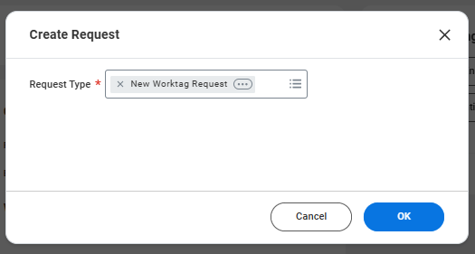

1. Answer the questions on the request, starting with **Describe the Request** by providing a valid business purpose of the worktag. Please be sure to include any important information relating to the request. Select **Submit**
   1. Describe the Request
   2. Department Name
   3. Select the type of Worktag to be created.
   4. Propose a title for the new worktag for review
   5. New Cost Center Manager
   6. New Cost Center Financial Analysts

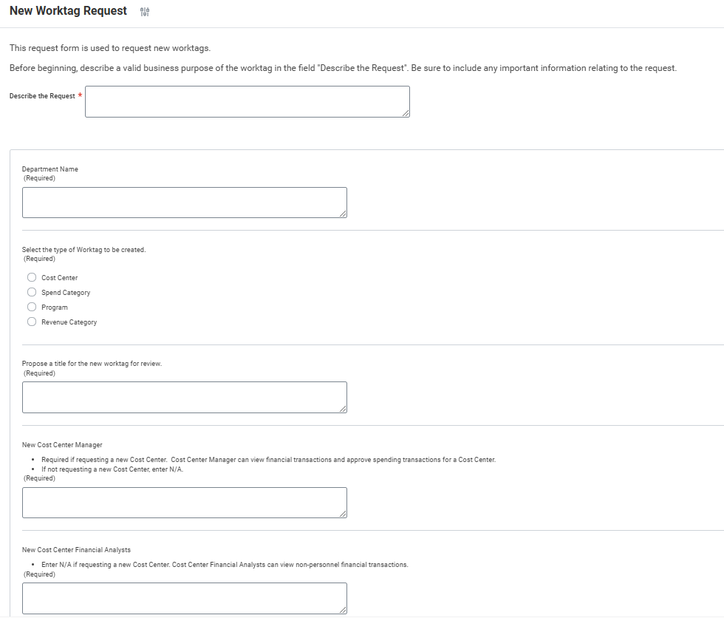

1. This will then route to the **Business Asset Accountant** for review and approval. At this time, the Business Asset Accountant can Approve, Send Back, Add Approvers or Deny the request.
2. The **Business Asset Accountant** will then get the task to **Complete Questionnaire 'New Worktag Request - Designated Code/Name** which is where they will note the designated code or name that has been assigned to this request.

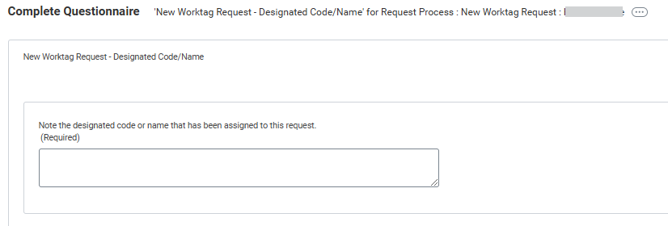

* 1. To view the request, click on the “related actions” button and right-click on the “event” and select “see in new tab”

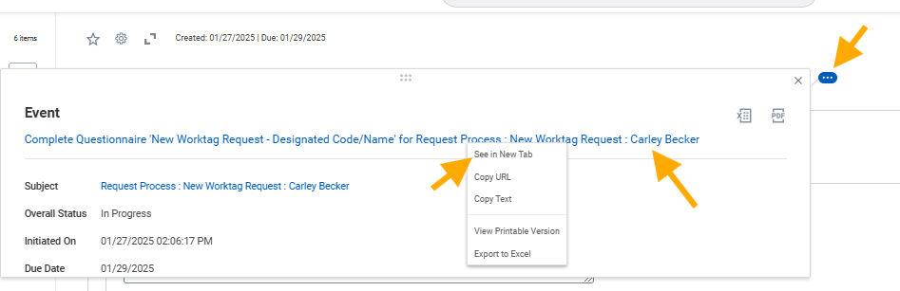

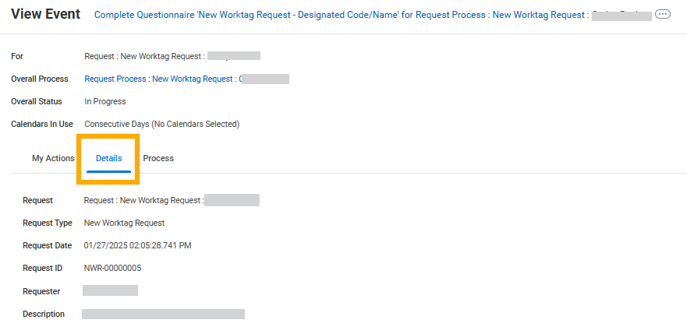

1. The **Business Asset Accountant** will then get the task to **Close Request**.

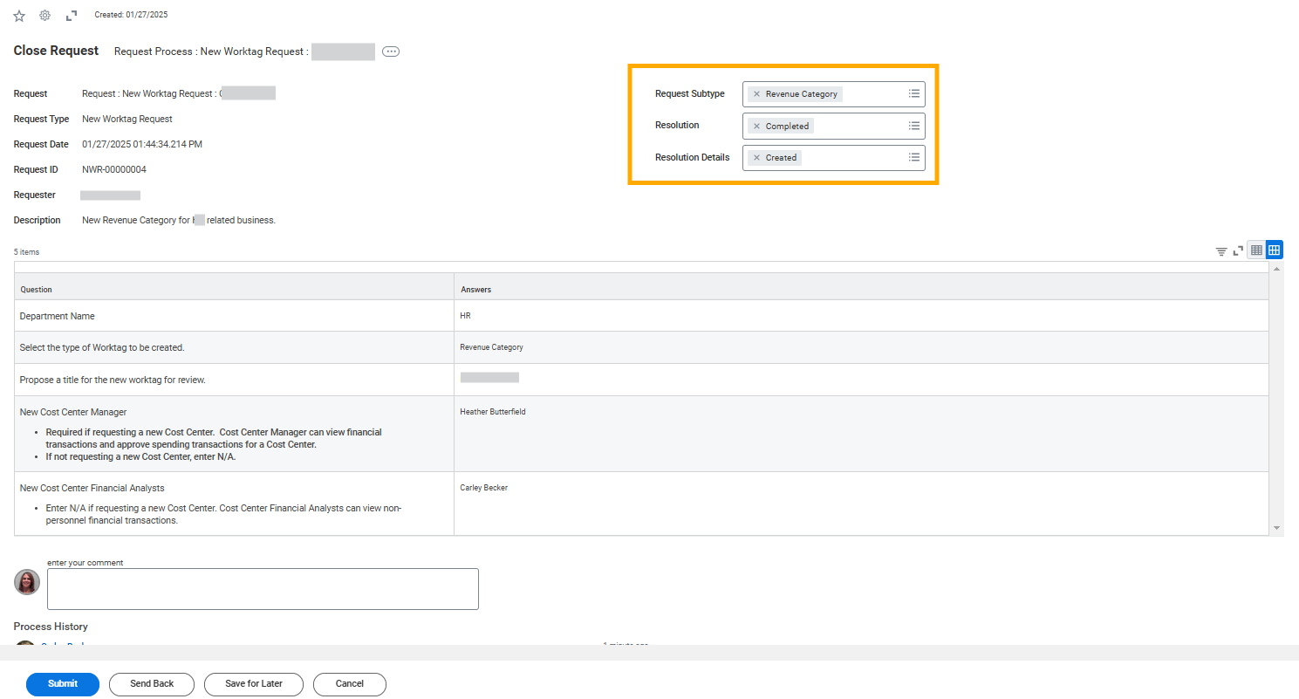

1. Once closed, the requestor will receive a notification that the Finance department will be in touch.

